



# Incident Response Platform Integrations

# Risk Fabric Function V1.0.0

Release Date: August 2018

Resilient Functions simplify development of the integrations by sending data from the Resilient platform to a remote program that performs an activity then returns the results to the function. The results can be acted upon by a script and the result of that becomes a decision point in the Resilient workflow.

This guide describes the Risk Fabric Function.

Overview

The Risk Fabric integration with the Resilient platform allows for the querying of Risk Ratings for Artifacts like IPs, Domains, and Users. Risk Models, Event Scenarios, and Action Plans can be pulled into Resilient and created as Incidents.

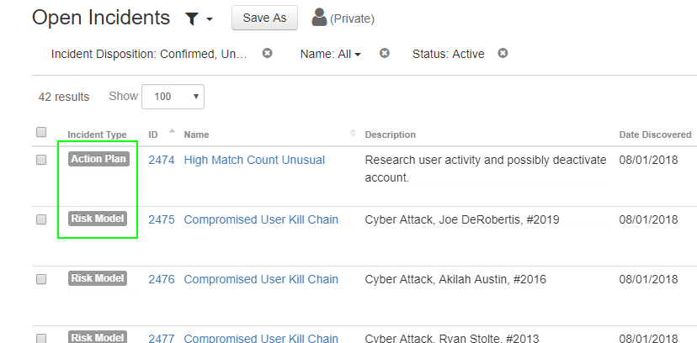

Automatically or manually perform Classifications and Mitigation actions on Risk Models, Event Scenarios, and Action Plans.

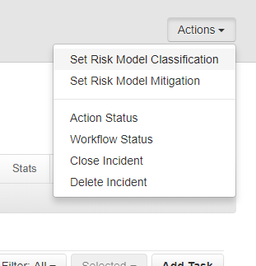 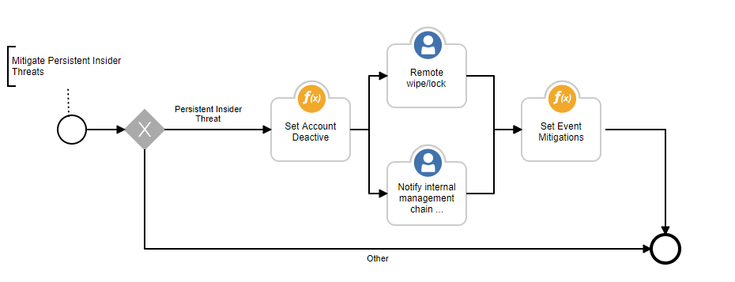

Setup

The following lists the system requirements:

* Python version 2.7.10 or later, or version 3.6 or later
* Resilient Circuits and Resilient Python libraries version 30.0 or later
* Resilient platform version 30.0 or later
* Risk Fabric version 6.5.1 or later

Perform the following to install and configure the function:

1. Ensure the environment is up to date:

sudo pip install --upgrade pip

sudo pip install --upgrade setuptools

sudo pip install --upgrade resilient-circuits

1. Install the required software for the function (if not already installed):

sudo pip install fn_risk_fabric-<*version*>.tar.gz

1. Add the function to the Resilient platform:

resilient-circuits customize

You are prompted to answer prompts to import functions, message destinations, etc.

1. From the account used for Integrations, use one of the following commands to configure the Risk Fabric settings. Use –c for new environments or –u for existing environments.

resilient-circuits config -c

OR

resilient-circuits config -u

1. Edit the .resilient/app.config file and section [fn_risk_fabric]:

server=<*risk fabric url*>

username=<*risk fabric api user*>

password=<*risk fabric api password*>

After completing the configuration steps, enter the resilient-circuits run command. The following is an example of the resulting messages indicating the successful connection to the Resilient platform and the loading of the Risk Fabric integration modules.

$ resilient-circuits run

2018-04-07 12:38:04,164 INFO [app] Configuration file: /Users/Integration/.resilient/app.config

2018-04-07 12:38:04,165 INFO [app] Resilient server: <host>

2018-04-07 12:38:04,165 INFO [app] Resilient user: <acct>

2018-04-07 12:38:04,165 INFO [app] Resilient org: <org>

2018-04-07 12:38:04,165 INFO [app] Logging Level: INFO

…

2018-04-07 12:38:05,418 INFO [component_loader] 'fn_risk_fabric.components.get_host_risk.FunctionComponent' loading

2018-04-07 12:38:05,419 INFO [component_loader] 'fn_risk_fabric.components.get_ip_risk.FunctionComponent' loading

2018-04-07 12:38:05,420 INFO [component_loader] 'fn_risk_fabric.components.get_user_risk.FunctionComponent' loading

2018-04-07 12:38:05,421 INFO [component_loader] 'fn_risk_fabric.components.get_risk_model_instances.FunctionComponent' loading

2018-04-07 12:38:05,422 INFO [component_loader] 'fn_risk_fabric.components.get_risk_model_instance_details.FunctionComponent' loading

2018-04-07 12:38:05,423 INFO [component_loader] 'fn_risk_fabric.components.get_action_plans.FunctionComponent' loading

2018-04-07 12:38:05,424 INFO [component_loader] 'fn_risk_fabric.components.set_event_classifications.FunctionComponent' loading

2018-04-07 12:38:05,425 INFO [component_loader] 'fn_risk_fabric.components.set_event_mitigations.FunctionComponent' loading

…

2018-04-07 12:38:05,435 INFO [actions_component] 'fn_risk_fabric.components.get_host_risk.FunctionComponent' function 'get_host_risk ' registered to 'risk_fabric_integration_functions'

2018-04-07 12:38:05,436 INFO [actions_component] 'fn_risk_fabric.components.get_ip_risk.FunctionComponent' function 'get_ip_risk ' registered to 'risk_fabric_integration_functions'

2018-04-07 12:38:05,437 INFO [actions_component] 'fn_risk_fabric.components.get_user_risk.FunctionComponent' function 'get_user_risk ' registered to 'risk_fabric_integration_functions'

2018-04-07 12:38:05,438 INFO [actions_component] 'fn_risk_fabric.components.get_risk_model_instances.FunctionComponent' function 'get_risk_model_instances ' registered to 'risk_fabric_integration_functions'

2018-04-07 12:38:05,439 INFO [actions_component] 'fn_risk_fabric.components.get_risk_model_instance_details.FunctionComponent' function 'get_risk_model_instance_details ' registered to 'risk_fabric_integration_functions'

2018-04-07 12:38:05,440 INFO [actions_component] 'fn_risk_fabric.components.get_action_plans.FunctionComponent' function 'get_action_plans ' registered to 'risk_fabric_integration_functions'

2018-04-07 12:38:05,441 INFO [actions_component] 'fn_risk_fabric.components.set_event_classifications.FunctionComponent' function 'set_event_classifications ' registered to 'risk_fabric_integration_functions'

2018-04-07 12:38:05,442 INFO [actions_component] 'fn_risk_fabric.components.set_event_mitigations.FunctionComponent' function 'set_event_mitigations ' registered to 'risk_fabric_integration_functions'

…

2018-04-07 12:38:05,729 INFO [actions_component] Subscribe to message destination 'risk_fabric_integration_functions'

…

2018-04-07 12:38:05,731 INFO [stomp_component] Subscribe to message destination actions.<org id>.risk_fabric_integration_functions

…

Resilient Platform Configuration

In the Customization Settings section of the Resilient platform, you can verify that the following Risk Fabric specific functions, workflows and rules are available in the Resilient platform by clicking their respective tabs.

* Functions, Workflows, and Rules
  + **Get Host Risk** – Query the Risk Rating Information for a hostname.
  + **Get IP Risk** – Query the Risk Rating information for an IP address.
  + **Get User Risk** – Query the Risk Rating information for a username.
  + **Get Action Plans** – Query the set of action plans for an account.
  + **Set Action Plan Classification** – Update Event Classification for an Action Plan.
  + **Set Action Plan Mitigation** – Update Mitigation statues for an Action Plan.
  + **Get Risk Model Instances** – Query the set of Risk Model Instances.
  + **Set Risk Model Classification** – Update the Event Classifications for a Risk Model.
  + **Set Risk Model Mitigation** – Update the Mitigation statuses for a Risk Model.
  + **Get Risk Model Instance Details** – Get the set of Event Scenario for a Risk Model Instance.
  + **Set Scenario Classification** – Update Event Classifications on Risk Model Event Scenarios.
  + **Set Scenario Mitigation** – Update Mitigation statuses on Risk Model Event Scenarios.
  + **Mitigate Persistent Insider Threats** – Example workflow for mitigating persistent insider threats.

Troubleshooting

There are several ways to verify the successful operation of a function.

* Resilient Action Status

When viewing an incident, use the Actions menu to view Action Status. By default, pending and errors are displayed. Modify the filter for actions to also show Completed actions. Clicking on an action displays additional information on the progress made or what error occurred.

* Resilient Scripting Log

A separate log file is available to review scripting errors. This is useful when issues occur in the pre-processing or post-processing scripts. The default location for this log file is:

/var/log/resilient-scripting/resilient-scripting.log

* Resilient Logs

By default, Resilient logs are retained at /usr/share/co3/logs. The client.log may contain additional information regarding the execution of functions.

* Resilient-Circuits

The log is controlled in the .resilient/app.config file under the section [resilient] and the property logdir. The default file name is app.log. Each function creates progress information. Failures show up as errors and may contain Python trace statements.

Support

For additional support, contact [support@resilientsystems.com](mailto:support@resilientsystems.com).

Including relevant information from the log files will help us resolve your issue.